Research Question: What impact do different layer normalisation methods (Post-LN vs. Post-PN vs. Post-BLN) have on the training effectiveness and performance of decoder-only transformer architectures (e.g. GPT-2)?

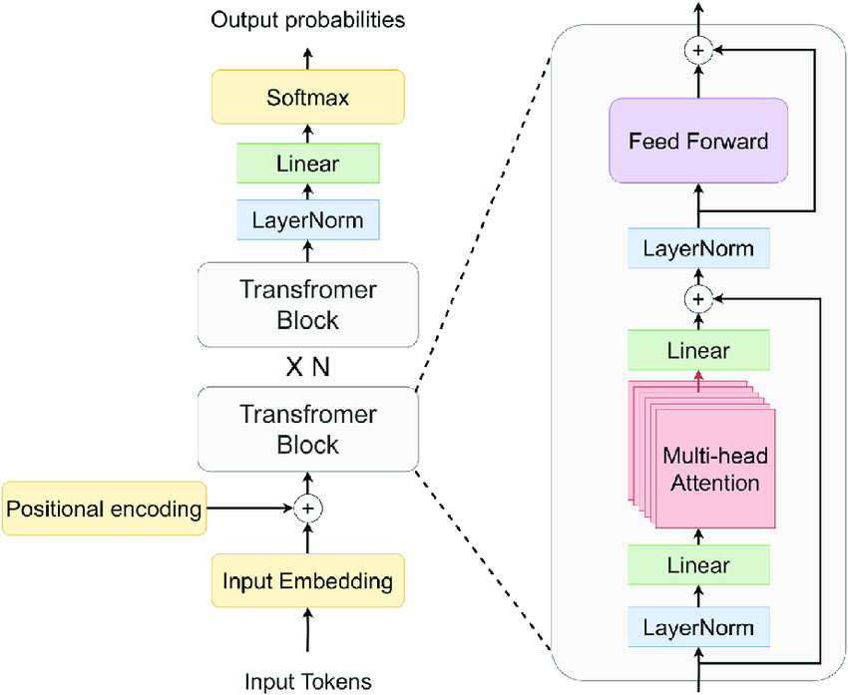

| (100 words)  Introduction - Deep Learning and Decoder-only Transformers |
| --- |
| (400 words)  Background Information - How decoder-only transformers work   * Tokenizer and Positional embedding * Q, K, V and self attention ++ attention is all you need paper * non-linear (very brief introduction) * Feedforward (very brief) * layer normalisation, briefly touch on internal covariate * backpropagation, optimisers |
| (175 words)  Background Information - Layer Normalisation   * why LN needed * brief history on CNN + RNNs + BN (very brief only words) |
| (1000 words)  Theoretical Background - LN   * what does LN do (maths stuff begins)   + im expanding upon the work of BLN, but applying PN instead * RMSnorm vs PN vs LN vs BLN/PLN (m)   + explain their differences   + show architecture, differences   >> Formulates hypothesis here, based on differences, etc. |
|  |
| (500 words)  Experimental methodology and materials   * GPUs → Ubuntu, Nvidia A100, 96x-AMD-CPUs * PyTorch, implemented GPT-2 based on Karparthy’s course   + my modifications, using GPT-4 tokenizer instead. why? (150 words)   + torch.compile explanation ← speeding up (50 words?) ++ FLASH attention, CUDA speed up   + gradient checkpointing, HF   + Datasets → fineweb.edu     - upload to HF   + model sizes (n-embd) 128m, 753m, 1.5B   + sequence length – 1024 to 4096 * Implemented layer normalisation by code, and using sIncerass’ code, and facebook’s RMS code, and personal implementation of BLN (substituting) |
| Experimental Results and Reflection |
| (1550 words)  Analysis   * Evaluating metrics   + BLEU,   + hellaswag?   + fine-tuning for a few tasks * Raw Result Analysis * Experimental Analysis and Limitations * Conclusion |
| (275 words)  Evaluation and Improvements   * Further improvements   + larger models, more variations, larger token context   + better fine-tuning ?   + multi-modal ? (a lot more compute will be needed) * Evaluation   + better fine-tuning techniques probably will cause more impacts   + probably futile to be doing little optimisations like this? as better to instead wait for even stronger compute, allowing for newer architectures to be used |
|  |